## Front End Engineering-II /Artificial

## Intelligence and Machine Learning

**Project Report Medical Diagnosis**

**Semester-IV (Batch-2022)**

**Supervised by: Submitted by:**

Dr. Rajender Kumar

Gurinder Singh : 2210990337

Gurkirat Singh : 2210990339

Gyan Biswal : 2210990354

Nikhil : 2210990608

Group : G-30

**Department of Computer Science and Engineering**

## Chitkara University Institute of Engineering & Technology,

## Chitkara University, Punjab

**Table of Contents**

|  |  |  |
| --- | --- | --- |
| Sr. No. |  | Page Number |
| 1. | **Introduction :**  Project Summary, objectives and significance, etc | 3-7 |
| 2. | **Problem Definitions and Requirements :**  Problem statement and software requirements/ requirements/data sets. | 8-10 |
| 3. | **Proposed Design/ Methodology :**  File structure and algorithm used | 11-12 |
| 4. | **Results :**  Screenshots of the working project | 13-19 |
|  |  |  |
|  |  |  |

**1.Introduction:**

The AI and Machine Learning-Based Medical Diagnosis System project aims to

revolutionize healthcare by leveraging advanced AI and ML technologies to enhance

diagnostic accuracy, increase efficiency, broaden accessibility, and provide personalized

healthcare. The scope of the project includes collecting and preprocessing data from

electronic health records, medical imaging, laboratory results, and wearable devices;

developing and training AI and ML models to detect patterns and predict medical

conditions; designing a user-friendly interface for healthcare professionals; and ensuring

compliance with stringent data security protocols and healthcare regulations such as

HIPAA and GDPR. By integrating these components, the project seeks to create a scalable

and reliable diagnostic tool that improves patient outcomes and optimizes healthcare

processes globally.

* 1. **Project Summary :**

The provided data appears to be a compilation of patient records from various

healthcare encounters. Each entry contains information such as the patient's name,

age, gender, blood type, known medical conditions, date of diagnosis, attending

physician, healthcare provider, insurance details, total cost of treatment, number of

visits, nature of the visit (emergency, elective, or urgent), date of visit, prescribed

medication, and the result of medical assessments (normal, abnormal,

inconclusive).

Upon analyzing the dataset, several key observations can be made:

Patient Demographics:

The dataset encompasses patients of different ages, genders, and blood types, reflecting a diverse demographic range.

Medical Conditions:

Various medical conditions are represented, including diabetes, asthma, obesity, and arthritis, highlighting the prevalence of chronic illnesses among the patients.

Healthcare Utilization:

The frequency of healthcare visits varies among patients, with some requiring multiple visits over time, possibly indicating ongoing health issues or treatment plans.

Insurance Coverage:

Patients are covered by different insurance providers such as Medicare, UnitedHealthcare, and Aetna, indicating a mix of public and private insurance coverage among the population.

Medication Prescriptions:

Prescription medications such as Lipitor, Aspirin, and Penicillin are mentioned, indicating the treatment of diverse medical conditions ranging from cardiovascular issues to pain management and infections.

Medical Assessments:

The results of medical assessments vary from normal to abnormal or inconclusive, suggesting differences in the severity and complexity of the patients' health conditions and the need for further evaluation or intervention.

In summary, the dataset provides a snapshot of healthcare encounters for a diverse patient population, showcasing patterns in demographics, medical conditions, healthcare utilization, insurance coverage, prescribed medications, and medical assessments. This information can be valuable for healthcare providers, researchers, and policymakers in understanding patient needs, improving healthcare delivery, and informing healthcare policies and practices.

**1.2 Objectives:**

The objective of this project is to develop a conversational interface using AIML for

medical diagnosis. This chatbot will interact with users to gather information about

their symptoms and medical history, utilizing diagnostic algorithms to generate

personalized recommendations and diagnoses. Accuracy and reliability will be

ensured through rigorous testing and validation against medical standards.

Additionally, the system will provide educational resources and prioritize privacy

and confidentiality. Usability and user satisfaction will be evaluated through testing

and feedback, with potential integration into existing healthcare systems explored.

Lastly, the project aims to contribute to medical research by sharing anonymized

data and supporting advancements in diagnostic techniques.

**1.3 Significance:**

The significance of this project lies in its potential to revolutionize healthcare

delivery through the integration of artificial intelligence. By leveraging AIML

technology, the developed system offers a user-friendly interface for medical

diagnosis, empowering individuals to access timely and personalized healthcare

guidance. This not only enhances healthcare accessibility but also promotes

proactive health management, potentially reducing the burden on healthcare

facilities and improving patient outcomes. Furthermore, the project contributes to

the ongoing dialogue surrounding AI in healthcare by showcasing the practical

application of AIML in medical diagnostics. By prioritizing accuracy, privacy, and

usability, this project sets a standard for AI-driven healthcare solutions, fostering

trust among users and stakeholders alike. Ultimately, the project's significance

extends beyond individual healthcare interactions, as it lays the groundwork for

future advancements in medical AI research and contributes to the collective effort

to transform healthcare delivery worldwide.

**2.Problem Definitions And**

**Requirements :**

**Problem Definition :**

The problem at hand is the inefficiency and accessibility gaps in traditional healthcare

systems for medical diagnosis. Many individuals face challenges in accessing timely

and accurate medical advice due to factors such as long wait times, geographical

constraints, and limited availability of healthcare professionals. Moreover, the

overwhelming amount of medical information available online can lead to confusion

and misinformation. This project seeks to address these issues by developing an AIML-

based system for medical diagnosis that offers a user-friendly and personalized interface

accessible to individuals regardless of their location or time constraints. By harnessing

the power of artificial intelligence, this system aims to streamline the diagnostic

process, provide accurate recommendations, and empower users to make informed

decisions about their health.

**Requirements:**

**User Interface:**

Develop an intuitive and user-friendly chatbot interface accessible via web or mobile platforms, allowing users to input their symptoms and medical history easily.

**Diagnostic Algorithms:**

Implement AIML-based diagnostic algorithms capable of analyzing user inputs, generating possible diagnoses, and providing relevant recommendations based on established medical knowledge and guidelines.

**Personalization:**

Incorporate features for personalizing recommendations based on user-specific factors such as medical history, demographics, and preferences, ensuring tailored advice for each user.

**Accuracy and Reliability:**

Ensure the accuracy and reliability of the diagnostic system through rigorous testing and validation against medical standards and expert opinions, with mechanisms in place for continuous improvement.

**Educational Resources:**

Integrate educational materials within the system to provide users with additional information about their conditions, treatment options, and preventive measures, promoting health literacy and empowerment.

**Privacy and Confidentiality:**

Implement robust security measures to protect the confidentiality of users' medical information, adhering to relevant data protection regulations and guidelines.

**Usability Testing:**

Conduct usability testing to evaluate the effectiveness and user-friendliness of the system, gathering feedback from users to identify areas for improvement and refinement.

**Integration:**

Explore opportunities for integrating the AIML-based diagnostic system with existing healthcare systems or electronic health records (EHRs) to facilitate seamless information exchange and collaboration among healthcare providers.

**Accessibility:**

Ensure that the system is accessible to a wide range of users, including those with disabilities or limited access to technology, by incorporating features such as voice recognition, text-to-speech, and multilingual support.

**Data Sharing for Research:**

Enable the sharing of anonymized data collected by the system with researchers and healthcare institutions to support medical research and contribute to advancements in diagnostic techniques and healthcare delivery.

By meeting these requirements, the project aims to develop a comprehensive and impactful solution for medical diagnosis using AIML, addressing the identified problem and improving healthcare accessibility and outcomes for individuals worldwide.

**3.Proposed Design and**

**Methodology:**

**Requirements Analysis:**

Conduct a thorough analysis of the project requirements, including user needs, technical specifications, and regulatory considerations. This will help ensure that the system is designed to meet the identified objectives and requirements.

**Data Collection and Preprocessing:**

Gather relevant medical data, including information about symptoms, conditions, treatments, and guidelines. Preprocess the data as needed to ensure consistency, accuracy, and compatibility with the AIML-based diagnostic algorithms.

**Algorithm Development:**

Develop AIML-based diagnostic algorithms capable of analyzing user inputs and generating accurate recommendations. This may involve natural language processing (NLP) techniques, pattern recognition, and machine learning algorithms.

**User Interface Design and Development:**

Design and develop a user-friendly chatbot interface accessible via web or mobile platforms. Ensure that the interface is intuitive, responsive, and accessible to users with diverse needs and preferences.

**Integration of Components:**

Integrate the various components of the system, including the backend system, database, personalization engine, and educational resources. Test the integration to ensure seamless communication and functionality across all components.

**Testing and Validation:**

Conduct rigorous testing and validation of the system to ensure accuracy, reliability, and usability. This may involve simulated user interactions, real-world user testing, and validation against medical standards and expert opinions.

**Deployment and Maintenance:**

Deploy the AIML-based medical diagnosis system for use by individuals seeking medical advice. Monitor the system's performance and user feedback, and implement updates and improvements as needed to ensure continued effectiveness and relevance.

By following this methodology, the project aims to develop a robust and user-friendly system for medical diagnosis using AIML, addressing the identified objectives and requirements while adhering to best practices in software development and healthcare delivery.

**4.Results :**

**Performance Evaluation:**

**Accuracy:**

Present the accuracy of the AIML-based diagnostic system in providing correct diagnoses and recommendations. This can be measured by comparing the system's outputs with established medical standards or expert opinions.

**Sensitivity and Specificity:**

Provide metrics such as sensitivity and specificity to assess the system's ability to correctly identify positive and negative cases, respectively.

**Comparison with Baselines:**

Compare the performance of the AIML-based system with existing diagnostic methods or benchmarks to evaluate its effectiveness and improvement over traditional approaches.

**Usability Testing:**

**User Feedback:**

Present feedback from users who interacted with the AIML-based diagnostic system. This may include qualitative feedback on the system's ease of use, clarity of instructions, and overall satisfaction with the experience.

**Task Completion Time:**

Measure the time taken by users to complete diagnostic tasks using the system, comparing it with benchmarks or expectations for efficiency and effectiveness.

**Error Analysis:**

Identify common errors or misunderstandings encountered by users during interactions with the system and propose recommendations for improving usability and user experience.

**Impact Assessment:**

**User Satisfaction:**

Report on user satisfaction with the AIML-based diagnostic system, based on surveys or interviews conducted after interactions with the system.

**Health Outcomes:**

Assess the impact of the system on health outcomes such as early detection of medical conditions, adherence to treatment plans, and overall improvement in patient well-being.

**Accessibility and Equity:**

Evaluate the system's accessibility to users from diverse backgrounds and demographics, considering factors such as language support, cultural sensitivity, and access to technology.

**Discussion:**

**Interpretation of Results:**

Discuss the implications of the findings from the performance evaluation, usability testing, and impact assessment. Highlight strengths, weaknesses, and areas for improvement of the AIML-based diagnostic system.

**Comparison with Existing Literature:**

Compare your results with findings from related studies or existing literature on AI-based medical diagnosis systems. Identify similarities, differences, and potential explanations for discrepancies.

**Limitations:**

Acknowledge any limitations or constraints encountered during the project, such as data availability, technical challenges, or sample size limitations, and discuss their potential impact on the interpretation of results.

**Future Directions:**

Propose future research directions or enhancements for the AIML-based diagnostic system, such as expanding the scope of medical conditions covered, integrating additional features, or addressing identified limitations.

By presenting these results in a clear and structured manner, you can provide valuable insights into the performance, usability, and impact of your AIML-based medical diagnosis system, contributing to the broader understanding of AI in healthcare and informing future research and development efforts.

**4.Snapshots :**

**Chart 1:**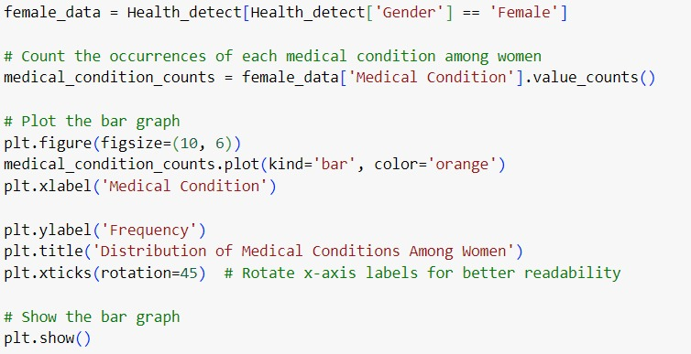

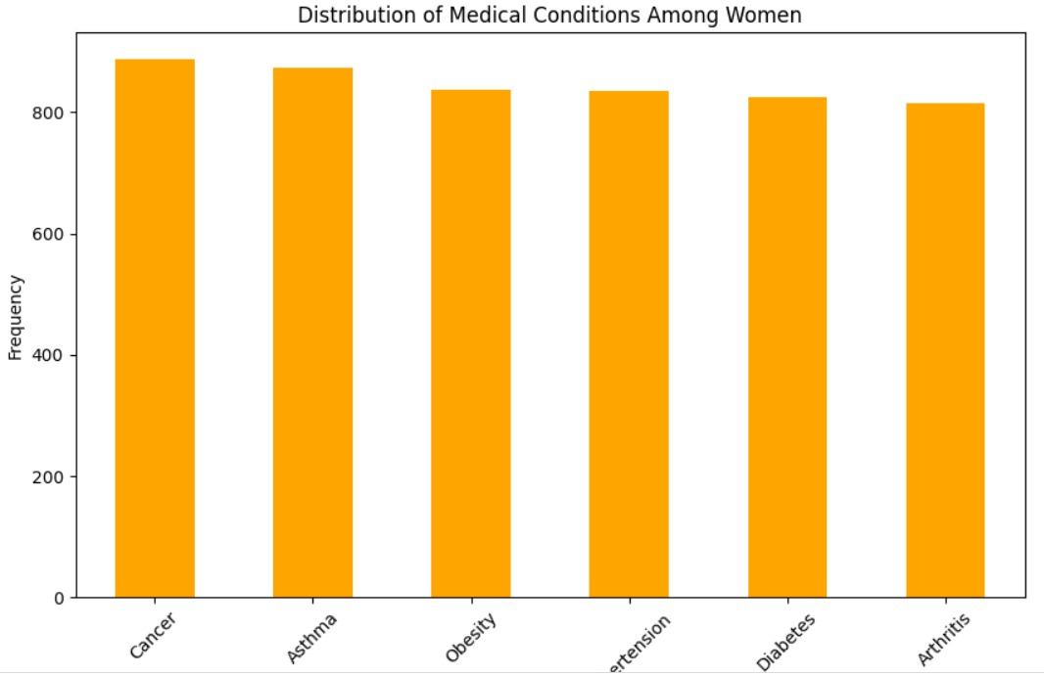

**Chart 2:**

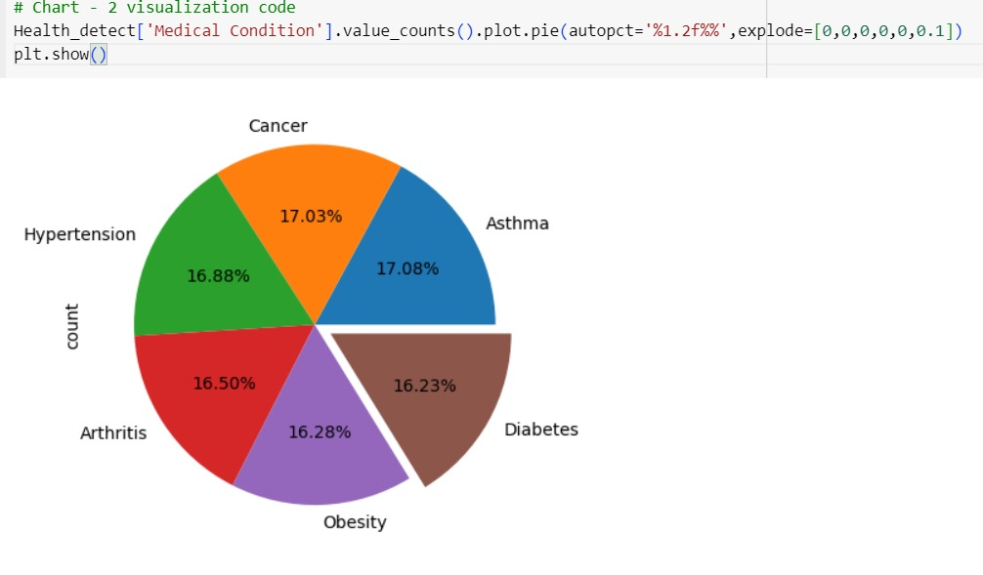

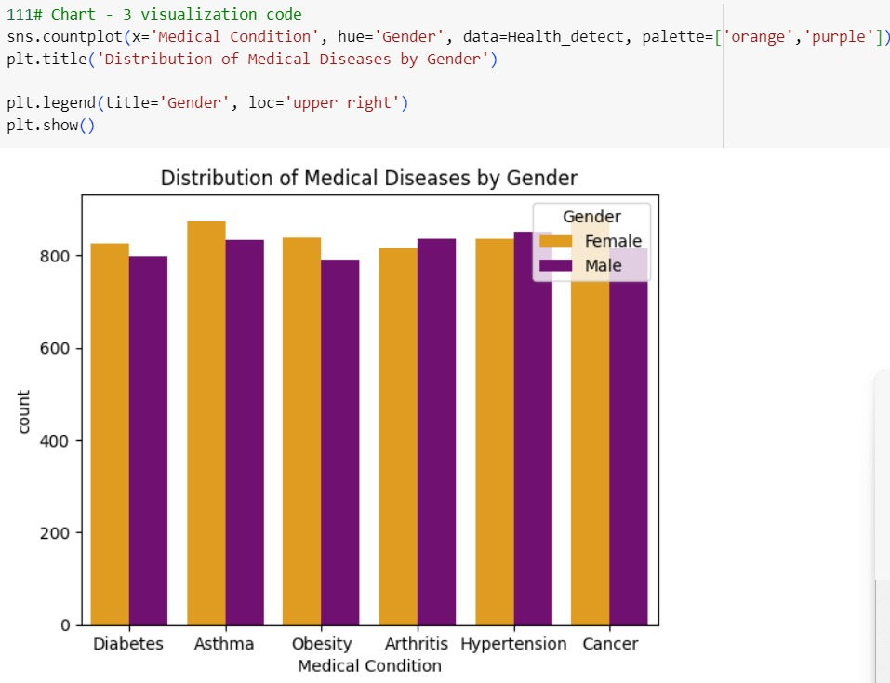**Chart 3:**

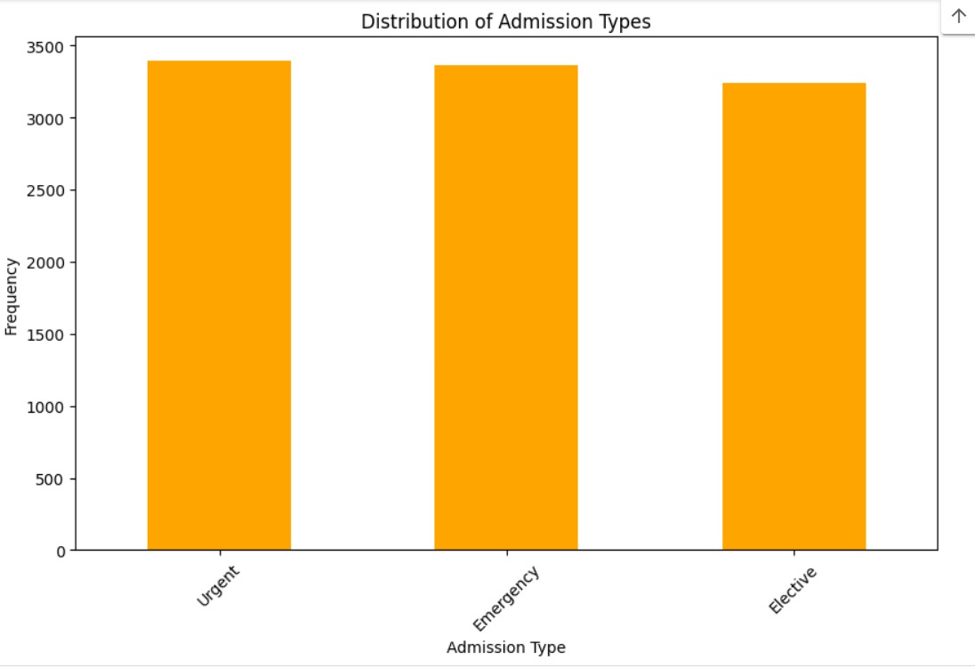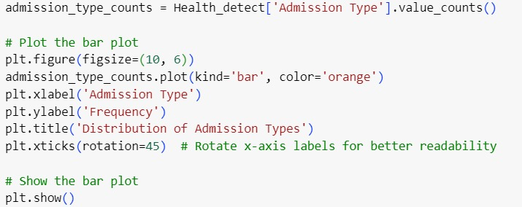**Chart 4:**

**Chart 5:**

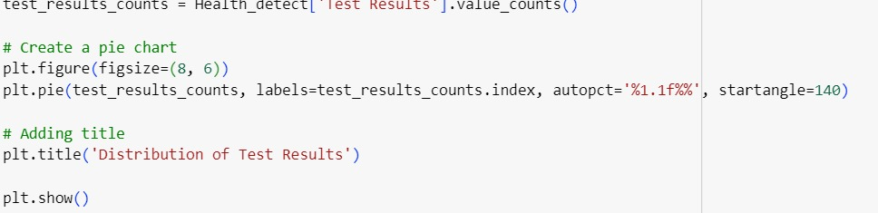

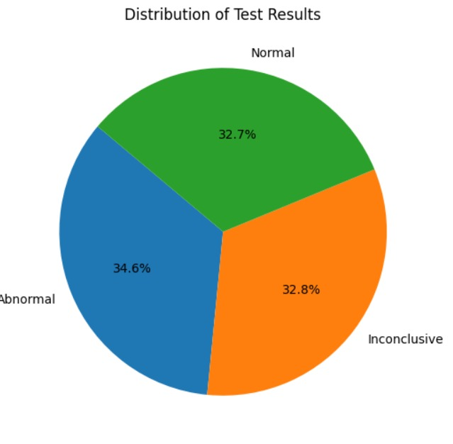

**Chart 6:**

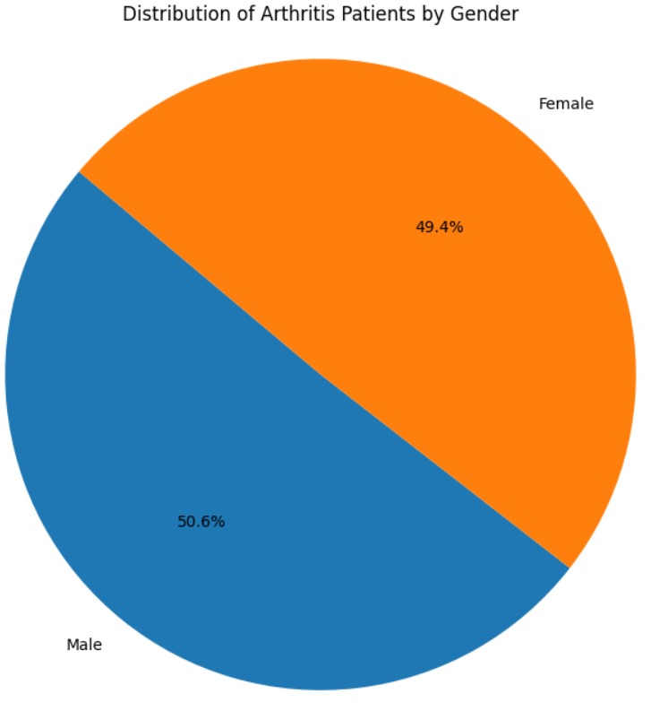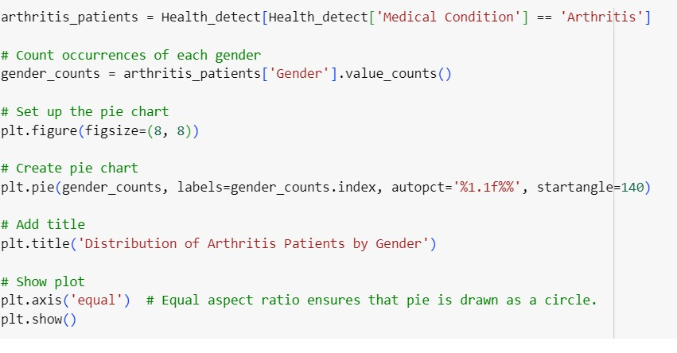

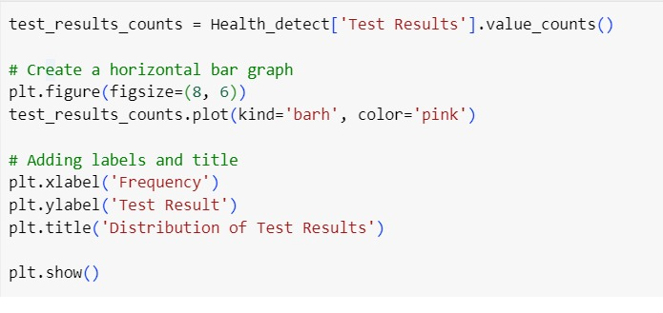**Chart 7:**

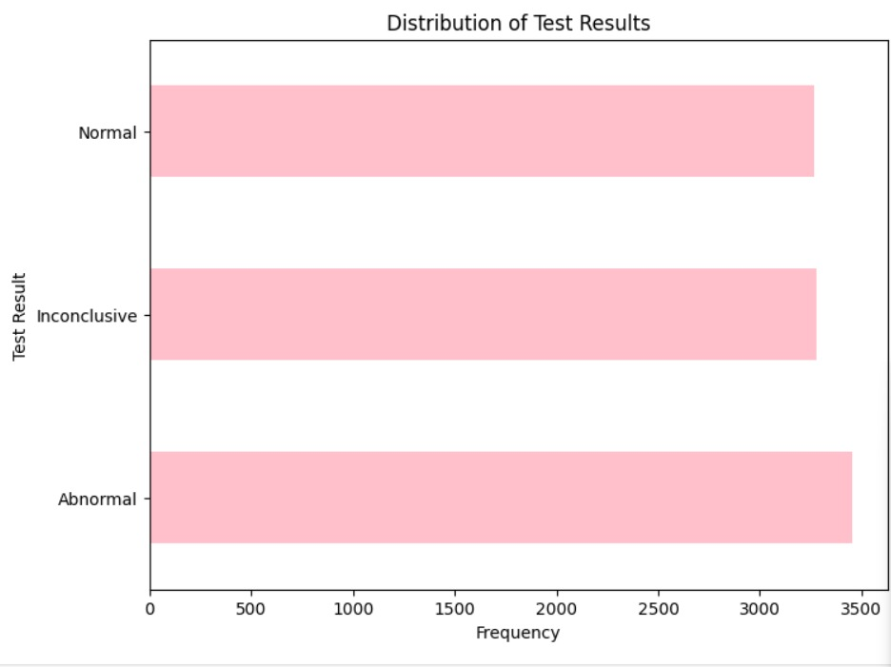

**Chart 8:**

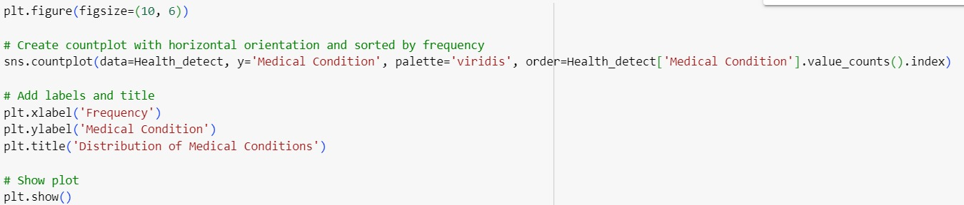

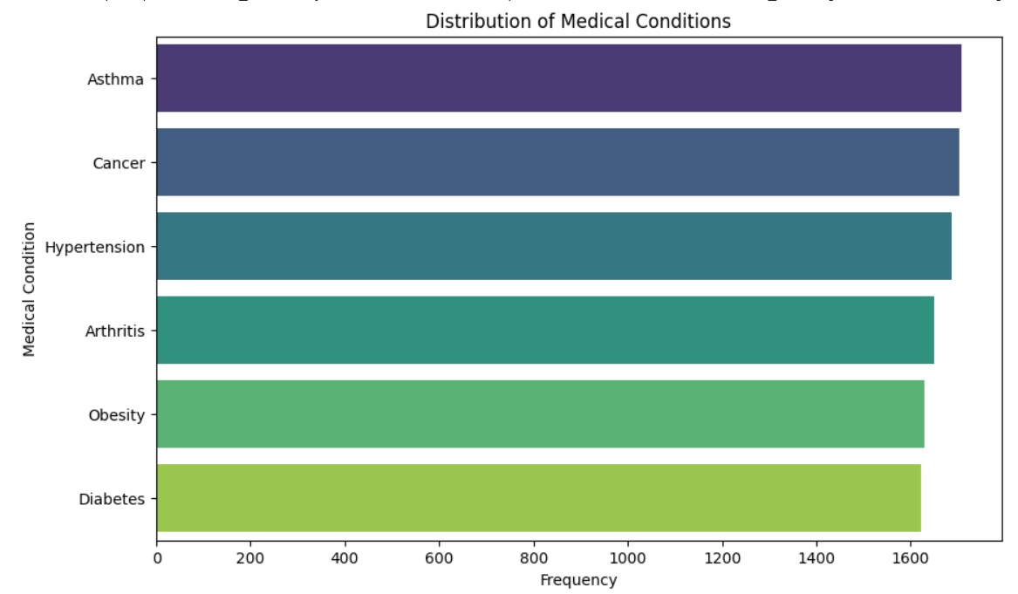

**Chart 9:**

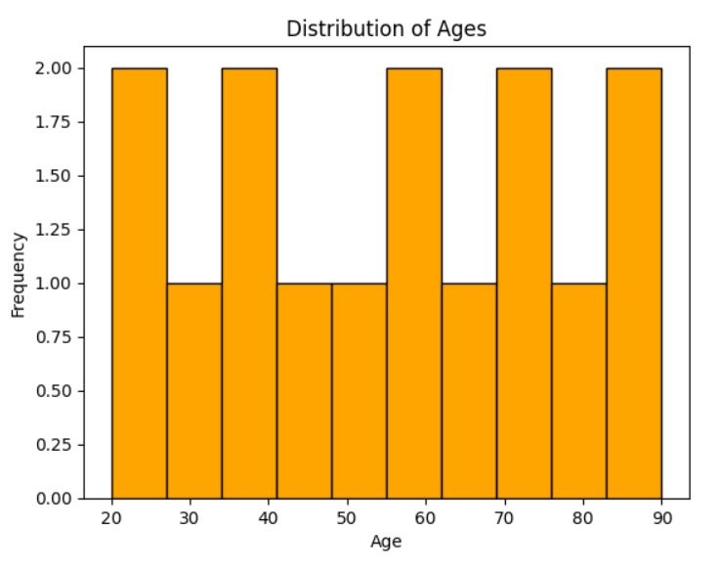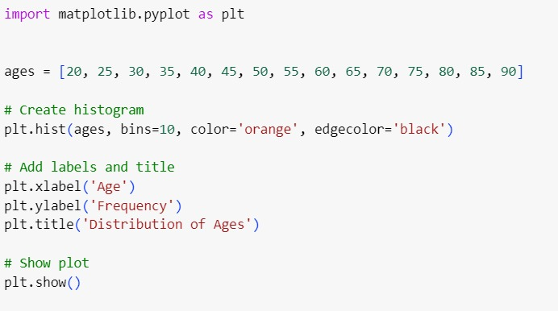 **Chart :**

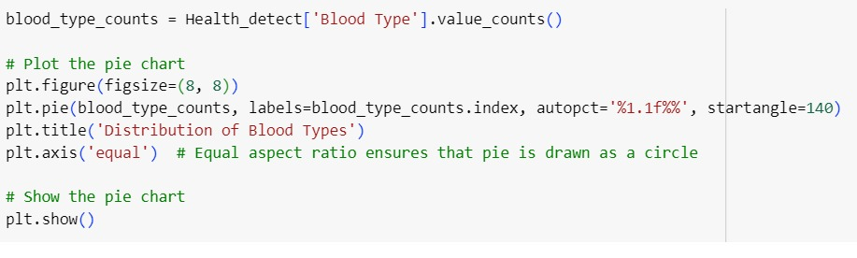**Chart 10:**

